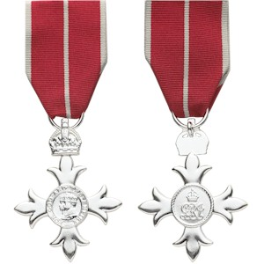
National Honours Nominations

Those people who are nominated and are awarded a National Honour such as an MBE or Knighthood receive something very, very special indeed.
They are personally recognised by The Queen for their work and contribution to Society. Both as individuals and their Community, people awarded a National Honour are widely acknowledged and bask in the glow of the tremendous accolade and Bristol is so proud of them and what they do. There is often publicity and media both written and television. A cheer as loud as from a sports stadium echoes around the town. It is a great moment.
Bristol is a diverse and amazing City with so much activity in so many places. We believe that the many people who contribute so much to making our City great that are missing out on the recognition they deserve. It is up to each and every one of us to consider those people that are involved in their communities, be it neighbours, colleagues and friends or volunteers supporting youth, elders, sick or healthy people in your community. Then you can nominate that person for a national honour.

You can nominate someone for an honour online
People get honours for achievements for reasons such as:
- making a difference to their community or field of work
- enhancing Britain’s reputation
- long-term voluntary service
- innovation and entrepreneurship
- changing things, with an emphasis on achievement
- improving life for people less able to help themselves
- displaying moral courage
You’ll need to write a detailed description explaining why you’re nominating them and why the individual has done something exceptional, extraordinary, selflessly, etc. Read the guidance on how to write a nomination. Nominating someone for a national honour is a confidential process. Only speak to the people that need to know and that can contribute to putting the nomination together.
You’ll also need:
- your nominee’s name, age, address and contact details
- details of relevant work or volunteering they’ve done
- details of any awards or other recognition they’ve received
- 2 or up to 4 supporting letters to back up your nomination - these should be from people who know the nominee personally
- a description of the impact the individual has made in their field of endeavor.

You can include any evidence you have of recognition your nominee has received for their achievements, for example articles, photos or letters.
The honours committee will review your nomination. You’ll get an acknowledgment - but you may not hear anything else for 12 to 18 months. All nominees will be checked by various government departments to make sure they’re suitable for an honour. This may include checks by HM Revenue and Customs (HMRC).
You can’t choose the specific honour the person that you nominate receives. This is decided by the honours committee where experts in their field review the quality of the nomination submissions.
Honours are announced twice yearly; for the New Year’s Honours’ list in January and for The Queen’s birthday in June.
Fill in the honours nomination form and send it to the Honours and Appointments Secretariat. The address is:
Honours and Appointments Secretariat
Cabinet Office
Room G39
1 Horse Guards Road
London
SW1A 2HQ

“Remember to keep your nomination a secret from the nominee. There are few surprises that are more heartwarming than to receive a letter inviting you to accept an Honour from The Queen,” says the Lord-Lieutenant Peaches Golding OBE.

